Chapter 16, Problem 39.

For the network in Fig. 16.62, find i(t) for t > 0.

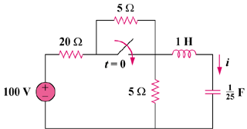
50 V

Figure 16.62
For Prob. 16.39.

